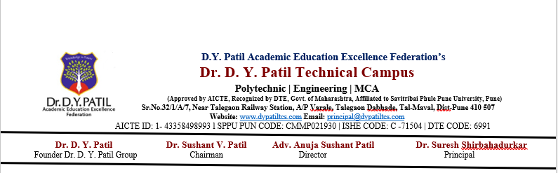
Practical No 4
Problem Statement
Develop a Java program to implement multiple inheritance using interfaces and demonstrate polymorphism by invoking methods through interface references

import java.util.Scanner;

interface Animal {
void eat();
}

interface Pet {
void play();
}

class Dog implements Animal, Pet {

@Override
public void eat() {
System.out.println("Dog eats food.");
}

@Override
public void play() {
System.out.println("Dog plays with a ball.");
}
}

public class MultipleInheritanceDemo {

public static void main(String[] args) {

Scanner sc = new Scanner(System.in);

System.out.print("Enter dog's name: ");
String name = sc.nextLine();

Dog d = new Dog();

// Polymorphism using interface references
Animal a = d;
Pet p = d;

System.out.println("\nDog's Name: " + name);

a.eat();
p.play();

sc.close();
}
}

